**Name – Shaurya Srinet**

**Reg No – RA2111032010006**

**Branch –CSE w/s in IoT**

**Section – T2**

**Object Oriented Design and Programming**

**Assignment: Week 10: -**

1. Write a C++ program to demonstrate throw an exception for division by zero condition.

Code: -

#include <iostream>

using namespace std;

int main()

{

int a,b;

cout<<"Enter two number: -\n";

cin>>a>>b;

try

{

if(b!=0)

cout<<"Division = "<<a/b;

else

throw b;

}

catch(int i)

{

cout<<"Exception caught: Division by Zero";

}

return 0;

}

Input and Output: -

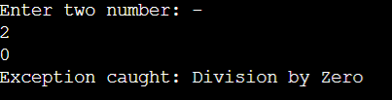

2. Write a C++ program to catch default exception for any given condition.

Code: -

#include <iostream>

using namespace std;

int main()

{

int a;

cout<<"Enter your Age: -\n";

cin>>a;

try

{

if(a>0)

cout<<"Age = "<<a;

else

throw a;

}

catch(int i)

{

cout<<"Exception caught";

}

return 0;

}

Input and Output: -

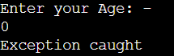

6. Write a C++ program to implement multiple try catch exception for any given condition.

Code: -

#include <iostream>

using namespace std;

int main()

{

int a,b;

float d;

cout<<"Enter two numbers: -\n";

cin>>a>>b;

try

{

if(b!=a)

{

d=float(a/b);

if(d<=0)

throw 'e';

cout<<d;

}

else

throw b;

}

catch(int i)

{

cout<<"Exception caught: Division by zero";

}

catch(char st)

{

cout<<"Exception caught: Division is less than 1";

}

return 0;

}

Input and Output: -

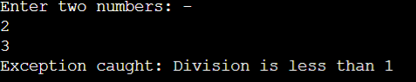

7. Write a C++ program to demonstrate re throw exception within exception handler.

Code: -

#include <iostream>

using namespace std;

void exception() {

try {

throw 0;

} catch (int i) {

cout << "\nException Caught: Wrong Input :" << i;

throw;

}

}

int main() {

int var = 0;

try {

exception();

}

catch (int ex) {

cout << "\nException Caught: Wrong Input :" << ex;

}

return 0;

}

Input and Output: -



8. Write a C++ program to throw exception by catching object as parameter inside catch

block.

Code: -

#include <iostream>

using namespace std;

class number

{

public:

int x;

};

int main()

{

number obj;

cout<<"Enter number \"1\": ";

try

{

cin>>obj.x;

if(obj.x!=1)

{

throw obj;

}

else

cout<<"Correct number entered";

}

catch(number a)

{

cout<<"Error "<<a.x<<" was entered instead of \"1\"";

}

return 0;

}

Input and Output: -

